**Dunedin Unit 203**

**AED Program**

**Fir St, Gravel Ct, Viola Ct, Neuport Path, Nugget Place**

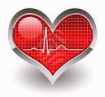

[**www.DunedinAEDs.com**](http://www.DunedinAEDs.com)

Read to learn:

* What it is?
* Why we need it?
* How it will work?
* Who will be responsible?
* How much it will cost?

**What is the proposed program?**

We would purchase four AED (Automatic External Defibrillators) which would be placed in waterproof cabinets on a resident’s property to provide rapid response to anyone who experiences a sudden cardiac or respiratory arrest in our neighborhood. We would also subscribe to Ready Alert. Ready Alert is the system used to contact responders.

**Why do we need an AED?**

Even though we are not far away from a fire station, *we cannot be sure that medics will be in a station when the need arises*, and the emergency team may have to come from a greater distance.

Statistics show that nationwide there is a 6-7% chance of surviving a cardiac arrest that occurs outside a hospital. The Villages has a much higher survival rate (over 40% for the past five years) largely due to the number of AED units located throughout the community at recreation centers, the 162 existing Villages AED communities, and the response time of medics.

The AED combined with immediate CPR has saved the lives of numerous people in the Villages. For every one minute delay in starting CPR and using an AED, the chance of survival decreases by 10%. Thus, if the medics arrive in seven minutes there is only a 30% chance of survival if a person has not had CPR administered.

**CPR BUYS TIME. THE AED BUYS LIFE!**

**What does the AED unit do?**

When sudden cardiac arrest occurs, the heart starts to flutter (fibrillate) but not enough to pump blood. CPR (chest compression) makes the heart pump and keeps oxygen flowing to the body, but will not “start” the heart. The AED is a battery operated device that determines whether a heart needs to be defibrillated (shocked) into resuming a normal rhythm. It gives audible commands and is so simple anyone who understands English can be taught its use in a few minutes.

**How would the program work?**

There are 159 homes in OUR AED community Unit 203 of Dunedin. We would like to have at least 30 persons trained as “responders.” The Villages Public Safety will provide CPR training free of charge. The more “responders” trained the better our community will be able to handle an emergency situation. In this way, one or more responders could be at home at any time. Each responder household would have ReadyAlert service. When a cardiac arrest occurs, a call is made to 911. The 911 operator, in addition to determining the nature of the emergency and dispatching the medics will see on their screen that the cardiac arrest occurred in OUR “AED Community” and would also send a message via ReadyAlert. While one or more responders would go immediately to the home, others would go to the AED unit and take it where needed. The AED is stored in a locked cabinet located on the responders, all of whom will have keys.

**Who would be responsible?**

The Villages Public Safety Department oversees and assists the program. They will order the equipment under their state contract, train the volunteers and provide continuing updates on training and equipment.

The responder volunteers would respond to administer CPR and/or pick up the AED unit on the way to the emergency. The ReadyAlert program has an annual service fee. The batteries in the AED’s are guaranteed to last 4 years before they need to be replaced. The AED is warranted for seven years.

There is a Citizens Bank account established, “Dunedin AEDS UNIT 203” in which all contributed funds are deposited and from which all invoices are paid.

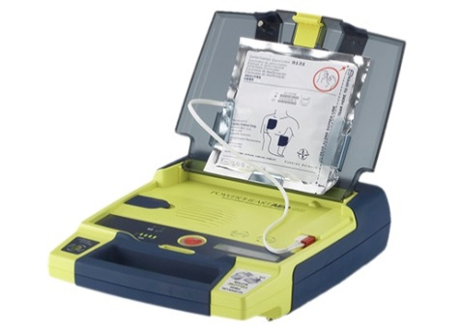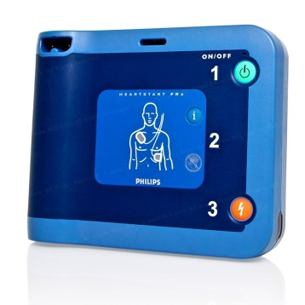

**What are the costs?**

The total estimated cost for Dunedin Unit 203 for the first 4 years is $9828.

Included in the cost is money to install hardened locks, keys and mounting hardware for the cabinets to insure the safety or our AED. Also included is the subscription service to Redi Alert that notifies our responders of an emergency.

**We are asking a $100 dollar contribution per household.**

***Remember, this is a one-time contribution.***

***This is NOT $100 annually***

***$2.08per month can give someone or***

***YOU***

***the opportunity to live longer.***

We feel this is a very good “insurance” plan, especially since it will handle all expenses for four, full years.

Please make checks payable to:

Dunedin AEDS Unit 203

And mail or deliver checks to:

Barbara Terwilliger

3787 Fir Street

The Villages, Fl.

32163

**SOME QUESTIONS**

**What if some people don’t participate?**

Because of liability concerns, **EVERY HOME** in OUR “AED” community –Dunedin Unit 203– will be covered in the case of an emergency regardless of whether they contributed or not.

**Why should I participate?**

The program needs your participation. It lowers the costs for all of US and increases your chance of survival if you go into cardiac arrest.

**Do I have to be a volunteer?**

No. Just if you want to.

**Is the AED difficult to use?**

It is virtually foolproof, and easy to use anyone who understands English can use it.

**Do I have any legal liability?**

Florida’s Good Samaritan laws protect any lay person who goes to the aid of a person in distress. Since the AED only “shocks” people who are clinically dead (i.e. not breathing) there is no risk of hurting someone. Florida also has two laws that indemnify individuals who use AED’s.

**What about mouth-to-mouth?**

Mouth-to-mouth is no longer recommended when doing CPR.

**How long is the CPR/AED training?**

2 ½ to 3 hours. The Villages Public Safety Dept. will schedule a training class (or classes) at no charge for those individuals who are part of the community wishing to be responders.

**Would we respond to all emergencies?**

No, just cardiac/respiratory arrests and just in area Unit 203.

**The 2014 Florida Statutes**

**Chapter 768**

**NEGLIGENCE**

**768.1325 Cardiac Arrest Survival Act; immunity from civil liability.—**

**(1) This section may be cited as the “Cardiac Arrest Survival Act.”**

**(2) As used in this section:**

**(a) “Perceived medical emergency” means circumstances in which the behavior of an individual leads a reasonable person to believe that the individual is experiencing a life-threatening medical condition that requires an immediate medical response regarding the heart or other cardiopulmonary functioning of the individual.**

**(b) “Automated external defibrillator device” means a lifesaving defibrillator device that:**

**1. Is commercially distributed in accordance with the Federal Food, Drug, and Cosmetic Act.**

**2. Is capable of recognizing the presence or absence of ventricular fibrillation, and is capable of determining without intervention by the user of the device whether defibrillation should be performed.**

**3. Upon determining that defibrillation should be performed, is able to deliver an electrical shock to an individual.**

**(c) “Harm” means damage or loss of any and all types, including, but not limited to, physical, nonphysical, economic, noneconomic, actual, compensatory, consequential, incidental, and punitive damages or losses.**

**(3) Notwithstanding any other provision of law to the contrary, and except as provided in subsection (4), any person who uses or attempts to use an automated external defibrillator device on a victim of a perceived medical emergency, without objection of the victim of the perceived medical emergency, is immune from civil liability for any harm resulting from the use or attempted use of such device.**

**History.—s. 1, ch. 2001-76; s. 3, ch. 2004-345; s. 3, ch. 2004-353; s. 3, ch. 2006-206; s. 2, ch. 2008-101.**

**MCj02868510000[1]**

**If you would like to be trained as a responder or for further information contact:**

**Gary Gross-** [**gag144@cox.net**](mailto:gag144@cox.net)**,**

**(860) 836-1216**

**Bob Spitzer-** [**bobspitzer02@gmail.com**](mailto:bobspitzer02@gmail.com)

**(919)602-3648**

**Barbara Terwilliger-treasurer-** [barbterwill@gmail.com](mailto:barbterwill@gmail.com)

**(440)731-7356**

**For general information visit our web site** [**www.DunedinAEDs.com**](http://www.DunedinAEDs.com)

**or contact:**

**Lt. John Longacre**

**The Villages Public Safety Department**

**205-8280 ext. 2910**

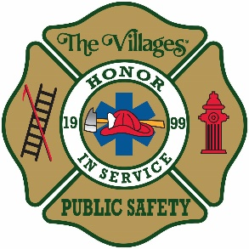

The Villages Public Safety Department

3035 Morse Boulevard

The Villages, Florida 32163

352-205-8280